**Research Methodology**

**Inspiration:**

I got inspiration from Safari animals, as they are the animals that thrive in grasslands or savannas. These animals include the elephant, the giraffe, the zebra, the lion, the hippopotamus, the rhinoceros, the impala and the leopard. Lion is the king of animals and very popular among peoples. The design of lion is famous in fashion industry that is why I selected this inspiration of safari animals. Some of my favorite fashion photography features models on safari in incredible outfits and surrounded by nature. In particular, I love the whole Lion King vibe that they achieve when they pose with big cats and other wildlife, though these can sometimes raise issues of animal welfare. Safari style is comprised of a color scheme of beige, creams, browns, and khaki. There can also be a sprinkling of animal print pieces. Moreover, my aim is to spread awareness regarding safari animals because safari animals are the most hunted and killed animals from all.

T**he Lion:**

The lion, also called the king of beasts, is an important animal in the safari. It’s scientific name is **Panther Leo** and it is second to the tiger in terms of size. In the wild, the average lifespan of lions is ten to fourteen years but in captivity or in zoos, they can live up to twenty years. Male lions die earlier than the females because they are usually involved in fights. The female lions are the ones which regularly hunt. A group of lions consisting of several adult males, related females and their offspring is called a “pride”. Lions are key predatory carnivores.

**The Leopard:**

The leopard is also a big cat like the lion. Its scientific name is **Panther padres**. This safari animal has short legs and a long body as compared to others. Male leopards are bigger in size as compared to female leopards. When you are wandering in a safari, you can easily distinguish a leopard from two other spotted cats (the cheetah and the jaguar) based on the distribution of their body spots. If safari is in South Africa, the rosettes on the leopard’s coat would seem square mostly. If your safari is in East Africa, its rosettes would seem more circular unlike East Africa. Leopards may hunt and eat anything they are not like lions when it comes to eating, which gives them the label “opportunistic” hunters.

**The Zebra:**

The zebra is known for it’s unique attractive white and black stripes. This safari animal’s name is from the old portuguese “zevra” meaning wild. Below three zebra species are existing

1. The plains zebra
2. The mountains zebra
3. The Gravy’s zebra

The zebra’s stripes are believed to serve as a means of identification, camouflage, and protection from the blood-sucking flies. Zebras get their food by grazing on grasses but they can also eat herbs, shrubs, leaves and bark.

**The Elephant:**

The elephant is the largest land mammal. Despite their massive size, elephants are herbivores and may spend up to 16 hours a day merely eating.

These are only three species still alive :

1. The African bush elephant
2. The African forest elephant
3. The Indian (or Asian) elephant.

The elephants are called browsers because they feed on leaves, barks, and fruits of shrubs and trees. Because their large bodies, they have no known natural predator. However, lions may prey on calves or target weakened elephants occasionally. Unfortunately, elephants are now being threatened by human activities and poaching.

**The African buffalo:**

The African buffalo is also known as the Cap buffalo. These buffaloes can be easily seen in protected areas and national parks such as the Ngoro Crater and the Serengeti. These large and robust bovines belong to the famous Big Five, being described by hunters as being extremely dangerous animals to approach when they are wounded. Some even claim, that up to 200 people are gored and killed each year by buffalos. Male buffalos mostly weight over a ton, whereas females weigh around 500 kg. Some bulls can have a shoulder height of up to 1.6 meters and with body length can range from 1.5 to 3.5 meters. Males are generally black in color whereas the females tend to have a slight note of brown on their coats.

**Procedure**

DATA COLLECTION METHODS

There are two methods that I adopted to gather data for research i.e. primary research and secondary research.

Primary research is also called individual research. In which we collect data from multiple printing techniques of laser printing, screen printing, 3d printing, quick sketches, raw and continuous line drawing etc. Elements shapes like textures, shapes, patterns and adornments, photographs, collages, colors like watercolor, poster color, silk paint etc. and presentation visuals are mostly common. Secondary research holds previously existing data. They perceive from, magazines, books, internet, etc. The research involved primary and secondary as guided by my supervisor Madam Sadia.

I followed both ways throughout my data collection process. At First, I did the secondary type research in which I visited different types of websites to get high quality pictures that I needed (Pinterest, and google images). I also looked for some reference ideas of boards compositions from Pinterest. I had roughly stored 400 photographs. Subsequent, I researched at least 1000 + images for a great variety of images composed in boards. I deeply explored pictures of hunting, designer’s collection, safari animal inspiration and as well saved composition related images. Then stepped towards the next step of boards developments.

BOARDS DEVELOPMENT

**Manual board**:

Collect data from different websites and print those images on photo paper. Then, compose those images in the A3 sheet size. There are four manual boards, two theme boards, two inspiration boards.

**Adobe board:**

The images related to all the cards are composed in Adobe with different tools. Seventeen A3 size boards have been created.

**Theme boards:** 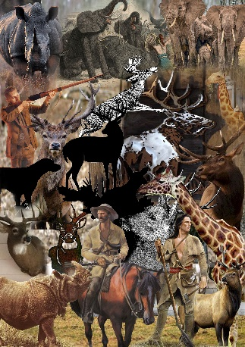

Icomposed five theme boards for my research collection which supported me to do my further fashion drawings. For the first board, I created an A3 size portrait orientation in adobe Photoshop. I opened the photo folder and picked images that I wanted to utilize in my board. I selected a picture of hunting in Tanzania. I added some broad, thin lines and frames of squares. I practiced to add software effects of shadows, blending, color grading and size variation. I built three boards according to that pattern and the next day I went to the supervisor. She checked my boards and suggested me to improve it more. I studied broad research of boards styles from Pinterest and saved enough collection. I began working on boards again. At such time, I built first board**.**Some rectangle shapes added vertically and horizontally for composition. Later I movedtowards my second board. I used eraser with soft edges to unfasten surroundings of figures.This board composed as images arranged at both sides and space at the center. I gave same background color and visual lines to boards so they seemed a set of work.

I applied design visuals of paint stokes, notes, lines and rectangle frames. My supervisor appreciated my effort when I moved to him to review my theme boards.

INSIPRATION BOARD

Afterwards, I stepped forward towards my inspiration boards. They were five in number. I selected pictures which had safari animals, and it provided a good feel and visual to my boards. The effects implemented were color grading, outer glow, bevel & emboss, pattern overlay, stokes, drop shadows and square and rectangle shapes.

Second board had the same blending effects with images of safari animals, zebra, lion, buffalo, leopard, elephant, confined in square and rectangular appearances with changes to some extent. Third board comprised a painting of safari animals and photographs of animals. Used brush of frame stamp and water splash strokes with multiple effects randomly. Applied 10 rectangle lines for making a great layout with Photoshop effects of inner glow, drop shadow and bevel & emboss.

**Mood:**

The mood conveys our feelings and expressions. There must be at least one image in the mood, 3 to 4 images can also be used. The color is chosen from the mood board.

My superintendent instructed me that mood board had a feeling and colors with the percentage used in the collection. A mood board is a type of visual presentation or a collage consisting of images, text, and samples of objects in a composition. It can be based upon a set topic or can be any material chosen at random. A mood board can be used to convey a general idea or feeling about a particular topic. They may be physical or digital, and can be effective presentation tools. Added more, the standards of color choice were to analyzed the color psychology, connected direct or indirect to the mood. I selected hues of orange, brown, violent, black, green.

At visit to the supervisor for approval, she asked me that is this color suitable for collection? said OK, when my answer was yes. Soon after I was confused after consulting my mood with different lecturers, their perception about mood was that it's an abstract feel and we didn't perceive save endangered species as a mood. Therefore, I decided to switch it and (sensitize) as mood. I picked orange, ivory brown and black including tones after studied the colors psychology a fresh .At that instant, I explored Google and found an image (Figure 19) depicted my mood.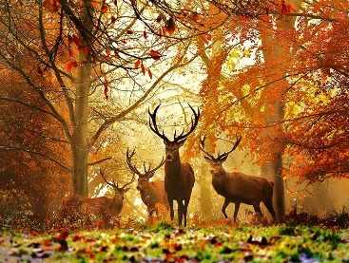

Concept Board

I invented a concept board of pictures of animals, quotation. After the meeting with the supervisor, she said include techniques and process in boards. Thus, I made another concept board entering pictures of animals, quotation, text and garments and the entire method I aspired to achieved.

.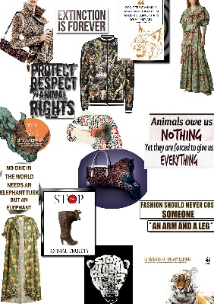

Other boards included colour board, trend board, authentication board, two silhouette boards, two accessory boards, three storyboards also created.

**Manual board** Collect data from different websites and print those images on photo paper. Then, compose those images in the A3 sheet size. There are four manual boards, two theme boards, two inspiration boards.

For hand-operated work, I separately printed some photographs picked from boards. Cut them according to the picture and stick on boards utilizing double-sided tape for surface variation. I drew line tracings on pictures added on boards with brown and black pointers. Furthermore, did watercolor, poster color, quotation writing.

Also I wrote a forecasting report of 4 pages. I explained the 2019-2020 fashion and color trends in it.

Creation of Illustrations and Drawings

We have created hundred sketches of pencils. They can be divided into four main categories. The categories are as follows

* Day wear
* Ready to wear
* Cocktail dress
* Evening gowns

For the developments of product four final illustrations with required techniques needs to be implemented.

### Pencil Sketches

Stepped towards pencil sketches, I managed a total of hundred sketches with twenty-five from each category i.e. cocktail dresses, evening gowns, daywear and ready to wear. I selected A - line and X - line silhouettes. In A-line silhouette, the dresses were made loose and evening gowns were drew fitted to the body. Daywear is a one - piece garment above the knee and evening gowns lengths to the ankle or floor length, cocktail dresses fall anywhere from above the knee to just below the knee with longer dresses for more formal events, and shorter cocktail dresses for semi-formal events. For pencil sketches, I had picked an illustration from internet and lowered the opacity in Photoshop and took out 100 prints of it on A4 size page. I drew front side of dresses with pencil on them which me saved time.

By the completion of the first category, daywear, visited to teacher for approval. Supervisor sadia Anwar said that dresses were so simple and suggested to download pictures of different cut lines, sleeves, gowns, trousers, skirts, bodice, frills, pleats and more for good sketches. By completed that task, I repeatedly drew ready to wear selecting different types of sleeves, frills, pleats, collars, etc. Supervisor checked my sketches and picked a few and merged the best elements of them to make five new sketches. After I was done with one category, I moved to the next one, day wear.

I picked elements from some reference images. Same like ready to wear, in second category also selected some sketches, merged their different elements.

The third and fourth classifications, cocktail and evening gowns, were also done. Total of twenty sketches were picked , five from each.

Colored Illustrations:

In this phase, I developed 4 to 5 styles with background and placed them on A3 size sheet using CAD software. One composition was accepted by Supervisor. After that I selected twenty-five sketches with different poses of illustrations on the front and back sides of A3 size canson sheets with a composition in which the front side is placed at the center of the sheet and backside was 1/3rd from the front, with the background. The decided colors were applied in form of watercolors on illustrations which appeared good.

**Technical Drawings**

Consequently, I proceeded towards technical drawings. My Supervisor guided me very nicely. In technical drawing we described the detailed construction of garments like the opening, closures, measurements and the panels of attires which did not appear in figures. I worked on the technical drawings of four final colored illustrations with full complete front and back. I explained the opening of dresses, the bodice panel of front and back. Described the construction of sleeves, trousers, the attachments of upper and lower torsos, the folding of fabric and the placements of stripes and zips .

Since now I was done with colored illustrations and their technical drawings, so I visited my supervisor’s office. He reviewed each illustration in detail and discussed some points.

For approval of final 4 fashion illustrations, there were two externals and two staff teachers in four different rooms sitting and they asked us questions while looking at our technical drawings and illustrations.